Ultima III Editor

Overview

The Ultima III Editor was written by Michael Mann, circa 1983. This Apple ][™ program allows you to edit your party, the characters and the Ultima III™ scenarios (maps, cities).

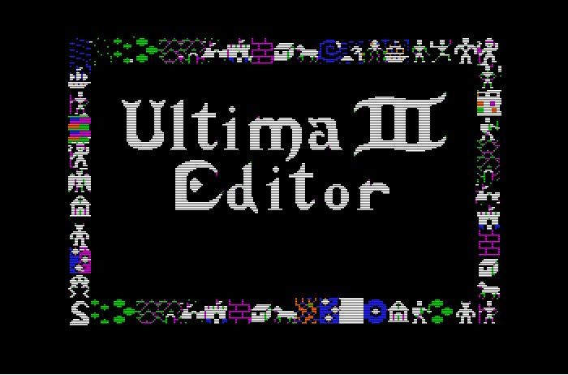

After the disk is booted and the splash screen has been displayed, the main menu is displayed:

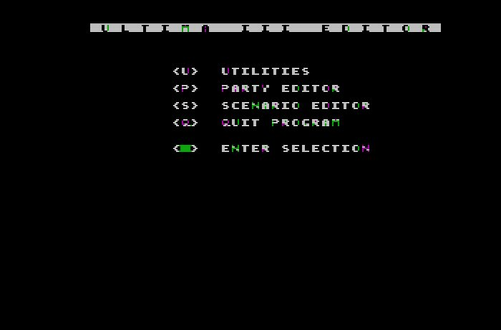

Hit U, P, S or Q to select the function. Remember that the Apple ][™ was uppercase, only—if running this in an emulator then you’ll need to type an uppercase letter to make the selection.

Ultima III™ was distributed on two diskettes: the Program Disk that was booted and the Scenario Disk that held the maps and the party and the characters. All of the various Ultima III Editor functions act on the Scenario Disk, so you may as well insert that disk into the second disk drive. Since the program always prompts for the disk # before accessing the disk to read or write, it’s OK if you only have one disk drive as you’ll always have the opportunity to swap disks. Note, however, that the Ultima III Editor Program Disk must be in drive #1 when you switch between sections since it dynamically loads, from diskette, the code for each main function.

Make sure to operate only on a copy of the Ultima III™ Scenario Disk! Saving from the Ultima III Editor will make permanent changes to the Scenario Disk and you’ll want to preserve the original diskette.

Navigation between and inside the main menus is by letter selection with the [ESC] key as a means of cancelling an operation or escaping from a section back to the main menu. Navigation within the Scenario Editor is much more complicated—more on that, later.

Utilities

The Utilities menu provides a set of functions that are useful when playing Ultima III™.

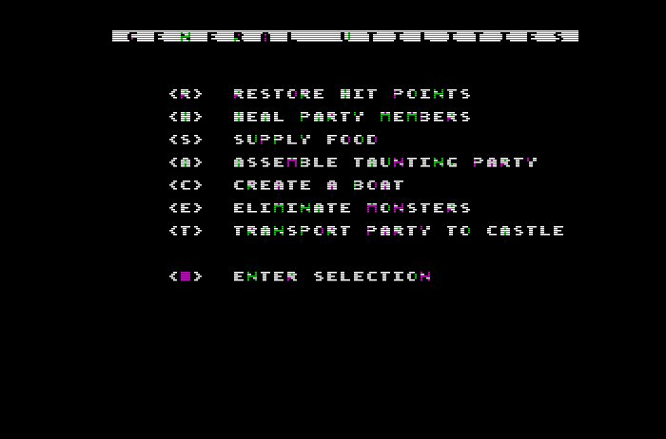

Restore Hit Points

This restores all hit points of each party member.

Heal Party Members

This heals all members of your party.

Supply Food

This supplies food to each party member. You will be prompted for the amount of food, a four-digit hexadecimal number.

Assemble Taunting Party

This creates a party of powerful characters that can freely roam (and win!) the game.

Create a Boat

A lot of travel in Ultima III™ is by boat! This function will create a boat on the water nearest your party’s current location. It will then instruct you which direction to travel to find the created boat.

Eliminate Monsters

This utility removes all monsters from the main map.

Transport Party to Castle

This brings the party back to the main castle.

Party Editor

The Party Editor allows you to edit characters and create a party.

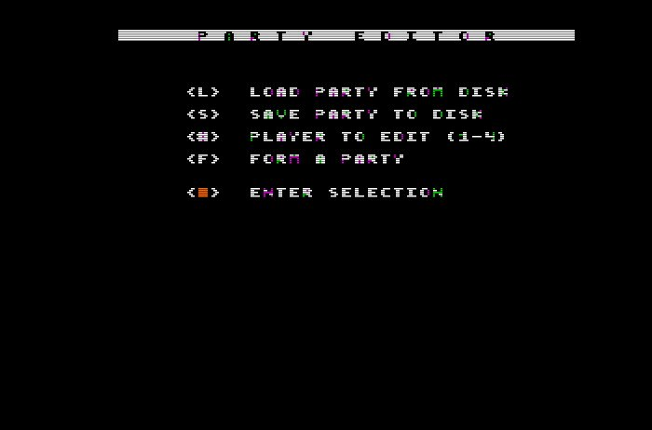

Load Party from Disk:

This function loads the current four-member party from the Scenario Disk. After having done so, you can edit party members one through four by selecting 1…4 on the keyboard.

Save Party to Disk:

This saves the current party to disk.

Player to Edit (1-4):

By selecting 1…4 you can edit the corresponding character in your party. See the instructions, below. You can only edit a character that was created in the game; there is no function to create a character from scratch. The reason for this is lost in the mist of time…

Form a Party:

This allows you to choose from the characters on the Scenario Disk and select four for your party.

Editing a Character

All of the attributes of a character are displayed and are available for editing. Use the left and right arrow keys to scroll through the various fields; hit [Enter] to edit a field. Attributes that require special editing will provide special input. E.g. the player type is selected by first letter, and the cards or marks are toggled with the [space] key.

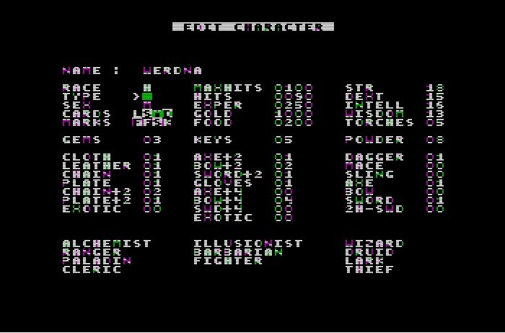

When finished, hit [ESC] and don’t forget to save the party!

Scenario Editor

The Scenario Editor is a lot of fun. Here you can edit maps and cities—you can change the landscapes, insert words, delete and create monsters, etc. It is here that you can greatly customize Ultima III™!

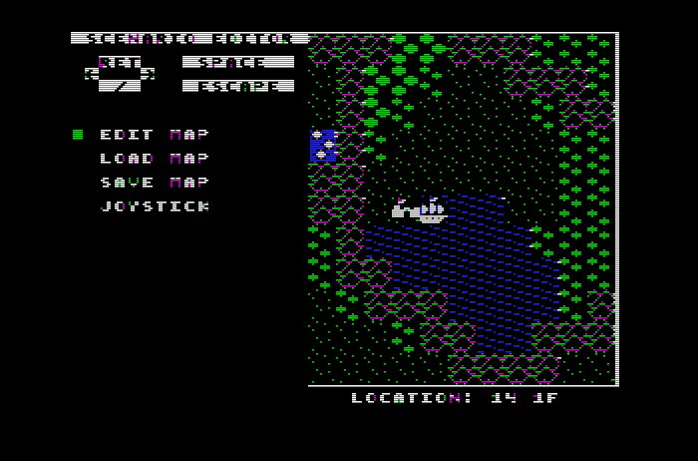

The first decision to be made is whether to edit by keyboard or by joystick; the bottom selection allows you to change to the different input mode.

Keyboard

If editing by keyboard, up-down-left-right is going to be [Enter], / (forward slash), left arrow and right arrow. The [space] bar selects items on the menus and the [ESC] key cancels or backs up. Although this arrangement seems strange, remember that the Apple ][™ had no numeric keypad or grouping of arrow keys.

Joystick

If editing by joystick then left and right on the joystick move through the menus, button 1 selects and button 2 escapes, and all four directions on the joystick navigate around the landscape. Note that the joystick may need to be calibrated to zero and that running at a speed other than the Apple’s original 1 Mhz may confuse the joystick reading routine. If running the Ultima III Editor in an emulator or on a II_{GS}™, you may need to set the processor speed to 1 Mhz rather than the fast Zip or Transwarp speeds.

Now the first screen allows you to load a map, edit the map and then optionally save the map.

Load Map

Select from the list of the Ultima III™ maps. If you’re in joystick mode, you must use the joystick (left and right) to select drive 1 or drive 2.

Save Map

When finished editing a map, select this function to save to disk.

Edit Map

Here’s where the fun is!

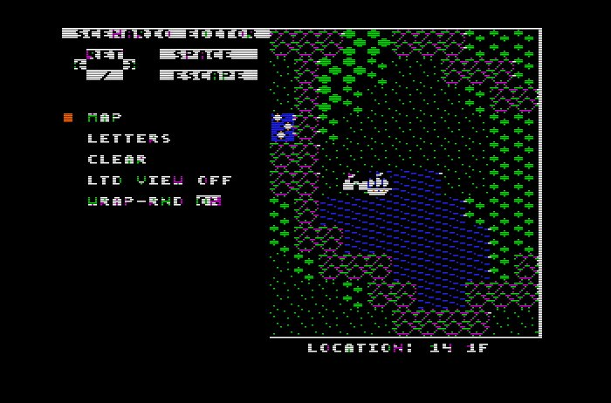

Map

Selecting Map puts you into move-edit-change mode. Editing a map is complicated; more on that, later.

Letters

This puts you into lettering mode where you can write phrases into the map. In this mode you can move around the map and when you locate the place where you want your phrase to begin you can type letters on the keyboard.

Clear

This clears the entire, current map.

Ltd (Limited) View [Off | On]

Normally, Ultima III™ used a line-of-sight system to display what the character could see and blot out what could not be seen. This can be toggled and the default is OFF since a fog of war is not useful when editing a map.

Wrap-Rnd (Wrap-Around) [On | Off]

This select whether navigating off the edges of a map scrolls around to the other side. The default is ON since this is more useful when editing.

Editing a Map

This map editing mode allows you to navigate around the map and alter the tiles (landscapes, monsters, etc.)

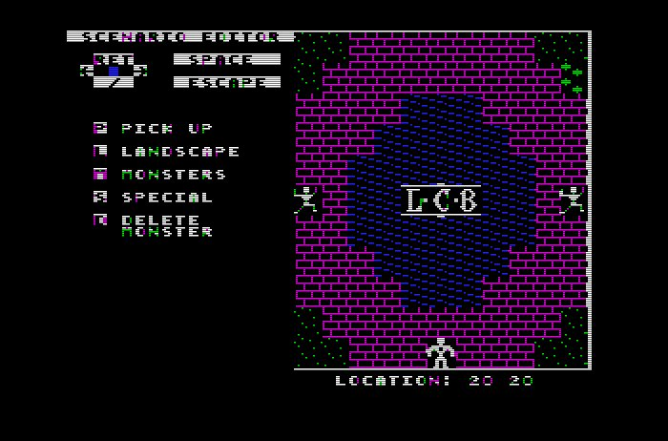

Movement is by [Enter]-slash-left-right on the keyboard or by movement of the joystick. Selection is by the [space] bar or button 1 and escape is by the [ESC] key or button 2. Once a tile has been selected, it stays on your “cursor” until escaped, and selection drops the tile on the map.

You can pick up the current tile, select from landscape tiles, select monsters, insert special tiles and delete monsters. Note that these are not keyboard shortcuts—the listing on screen is the key (hint) of what each letter means when you scroll through the options. This way the system works is that you begin a selection ([space], or button 1) and move up and down through P, L, M, S and D, and then immediately left and right through the list of tiles before selecting the tile with another [space] or button 1. For instance, to select a treasure chest you must (1) start the selection process, (2) go down-down-down to S for special, (3) move right-right-right to the treasure chest, and finally (4) select the tile with [space] or button 1. Confusing? Perhaps. Hey, it was 1983 and the code was written on an Apple ][+ with had neither mouse nor numeric keypad.

Pick Up

This will pick up the current tile under the “cursor.” The cursor is the centermost tile of the map. After having chosen the tile, you can move around and continue to drop the tile; in this way entire oceans or forests can be created very quickly.

Landscape

This selects from all of the various landscape tiles.

Monsters

This selects from all of the various monsters. After selecting a monster, you can only drop it where one already exists! When you drop a monster on one of Ultima III™’s monster locations, you then choose whether the monster should automatically attack, follow the player, move around in a random motion or stay still. E.g. aggressive monsters should attack; guards should remain still.

Special

This is a list of special tiles: castles, chests, etc.

Delete Monster

This allows you to delete a monster from the map.

Conclusion

Enjoy this blast from the past!

Mike

